Scope & Visibility

📌 Definition:
# Source: AI Source: Provided by: [Data Path: Persons Table -> ID Column: 1, Name_En Column: Motasem Essam] -> From: [Chatgpt (GPT‑5 Mini)] on [12/9/2025]
Scope and visibility define where variables and methods can be accessed in a program and who is allowed to access them.

🧠 Simple idea:
# Source: AI Source: Provided by: [Data Path: Persons Table -> ID Column: 1, Name_En Column: Motasem Essam] -> From: [Chatgpt (GPT‑5 Mini)] on [12/9/2025]
- Scope = Where you can use it 📍
- Visibility = Who can access it 🔐

🔍 Types of Scope:

📦 1. Local Scope
# Source: AI Source: Provided by: [Data Path: Persons Table -> ID Column: 1, Name_En Column: Motasem Essam] -> From: [Chatgpt (GPT‑5 Mini)] on [12/9/2025]
- Defined inside a method or block
- Accessible only within that block
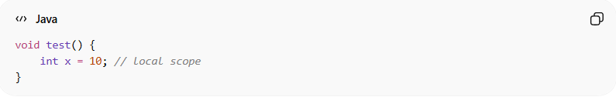
void test() {
int x = 10; // local scope
}

🧱 2. Class (Instance) Scope
# Source: AI Source: Provided by: [Data Path: Persons Table -> ID Column: 1, Name_En Column: Motasem Essam] -> From: [Chatgpt (GPT‑5 Mini)] on [12/9/2025]
- Defined inside a class, outside methods
- Accessible by all methods in the class
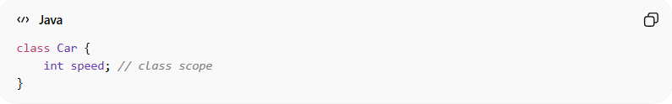
class Car {
int speed; // class scope
}

🌍 3. Global Scope (language-dependent)
# Source: AI Source: Provided by: [Data Path: Persons Table -> ID Column: 1, Name_En Column: Motasem Essam] -> From: [Chatgpt (GPT‑5 Mini)] on [12/9/2025]
- Accessible from anywhere in the program
- Common in some languages (not typical in Java)

🔐 Visibility (Access Modifiers):

🔒 Private
# Source: AI Source: Provided by: [Data Path: Persons Table -> ID Column: 1, Name_En Column: Motasem Essam] -> From: [Chatgpt (GPT‑5 Mini)] on [12/9/2025]
- Accessible only within the same class

🟡 Default (Package-private)
# Source: AI Source: Provided by: [Data Path: Persons Table -> ID Column: 1, Name_En Column: Motasem Essam] -> From: [Chatgpt (GPT‑5 Mini)] on [12/9/2025]
- Accessible within the same package only

🔵 Protected
# Source: AI Source: Provided by: [Data Path: Persons Table -> ID Column: 1, Name_En Column: Motasem Essam] -> From: [Chatgpt (GPT‑5 Mini)] on [12/9/2025]
- Accessible within the same package and by subclasses

🟢 Public
# Source: AI Source: Provided by: [Data Path: Persons Table -> ID Column: 1, Name_En Column: Motasem Essam] -> From: [Chatgpt (GPT‑5 Mini)] on [12/9/2025]
- Accessible from anywhere

📌 Example (Java):
# Source: AI Source: Provided by: [Data Path: Persons Table -> ID Column: 1, Name_En Column: Motasem Essam] -> From: [Chatgpt (GPT‑5 Mini)] on [12/9/2025]
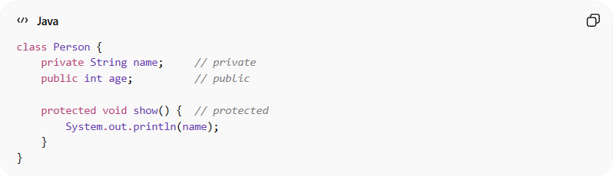
class Person {
private String name; // private
public int age; // public

protected void show() { // protected
System.out.println(name);
}
}

🆚 Quick Comparison:
# Source: AI Source: Provided by: [Data Path: Persons Table -> ID Column: 1, Name_En Column: Motasem Essam] -> From: [Chatgpt (GPT‑5 Mini)] on [12/9/2025]
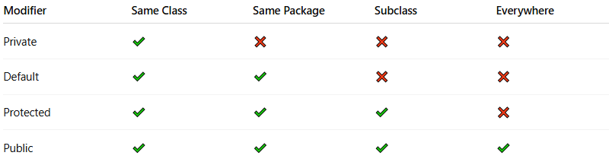
Modifier | Same Class | Same Package | Subclass | Everywhere
Private | ✔️ | ❌ | ❌ | ❌
Default | ✔️ | ✔️ | ❌ | ❌
Protected | ✔️ | ✔️ | ✔️ | ❌
Public | ✔️ | ✔️ | ✔️ | ✔️

🎯 Why scope & visibility are important:
# Source: AI Source: Provided by: [Data Path: Persons Table -> ID Column: 1, Name_En Column: Motasem Essam] -> From: [Chatgpt (GPT‑5 Mini)] on [12/9/2025]
- 🔒 Protect data (security)
- 🧩 Control access to code
- 🧠 Reduce complexity
- ⚙️ Improve maintainability

🎯 Summary:
# Source: AI Source: Provided by: [Data Path: Persons Table -> ID Column: 1, Name_En Column: Motasem Essam] -> From: [Chatgpt (GPT‑5 Mini)] on [12/9/2025]
Scope and visibility control where variables and methods can be accessed, helping to protect data and organize code effectively in OOP.

